Online Second-Hand Book Selling System

Team members:

01fm19mca025: Kavya Goudar

01fm19mca024: Prarthana Charankar

01fm19mca014: Priyanka Goudar

Class Diagram

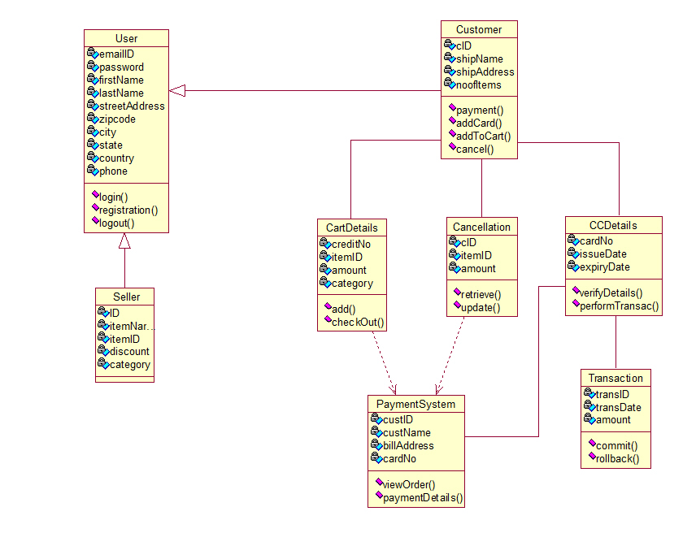

Use Case Diagram

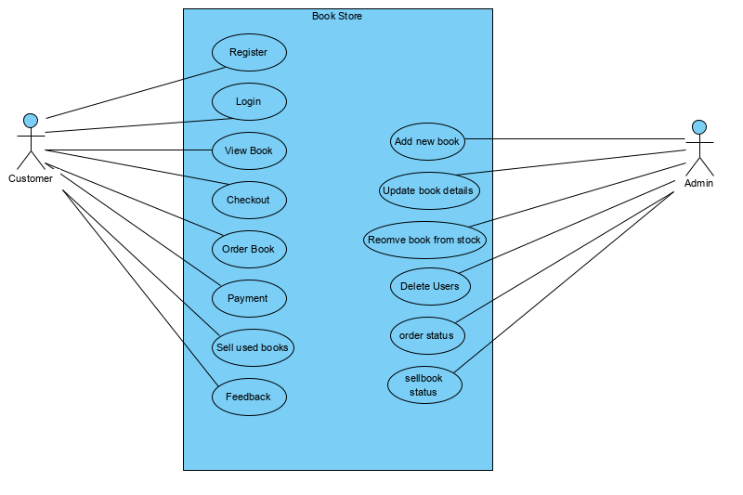

Sequence Diagram

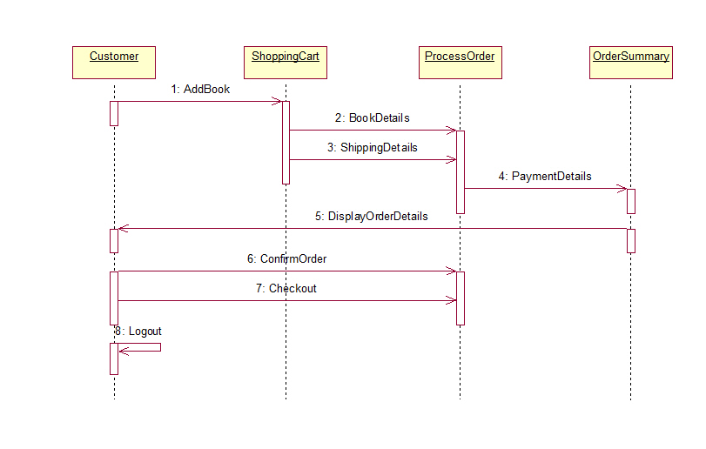

Activity Diagram

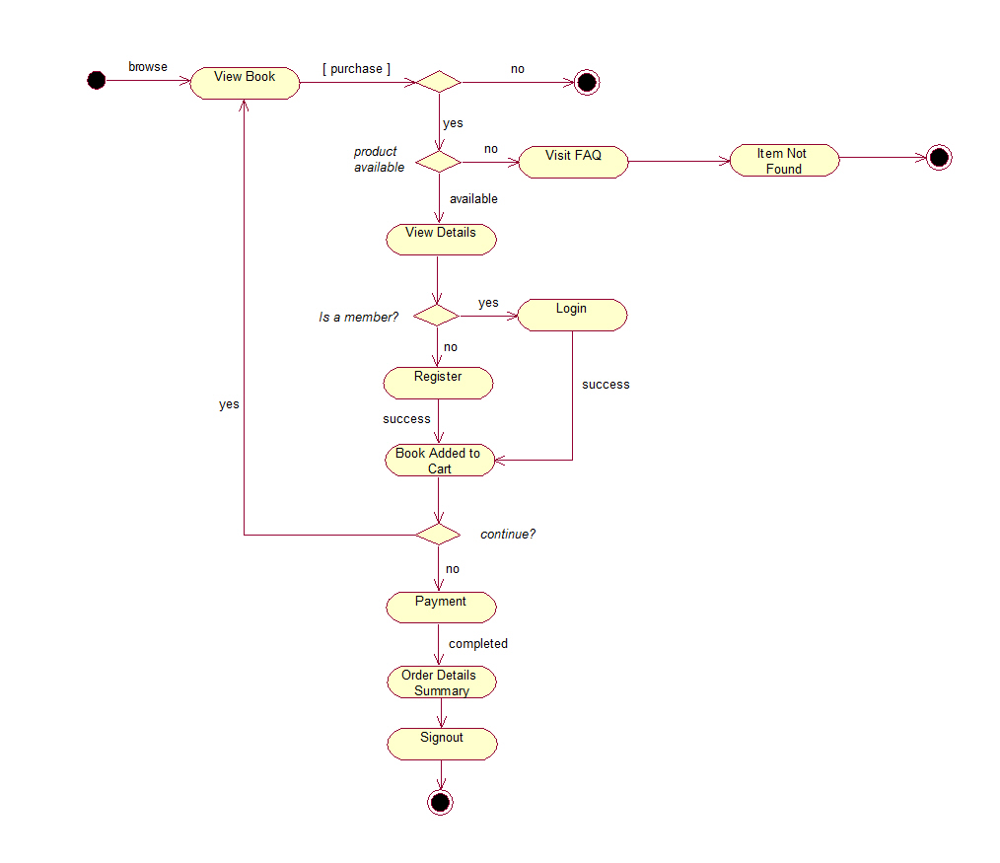

Collaboration Diagram

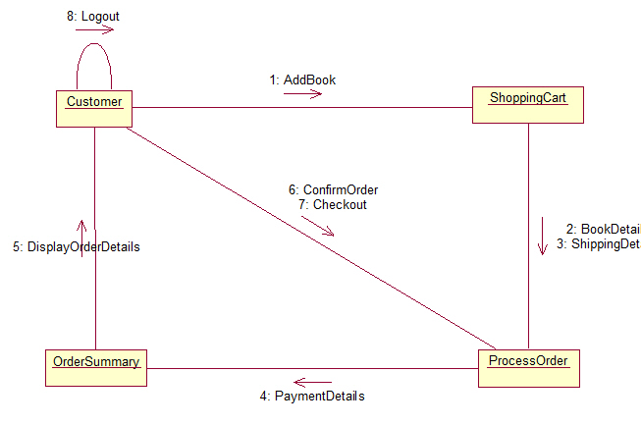

State chart diagram

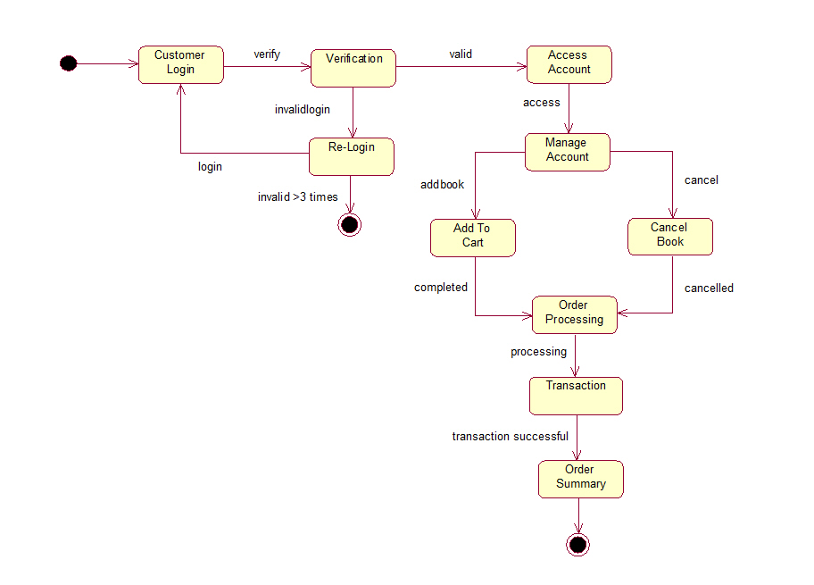

Swim lane Diagram

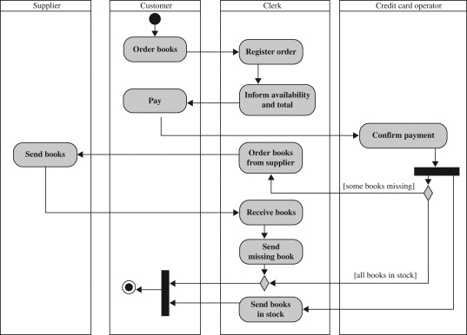

Component Diagram

